Graph

- terminology for directed, undirected, acyclic graphs

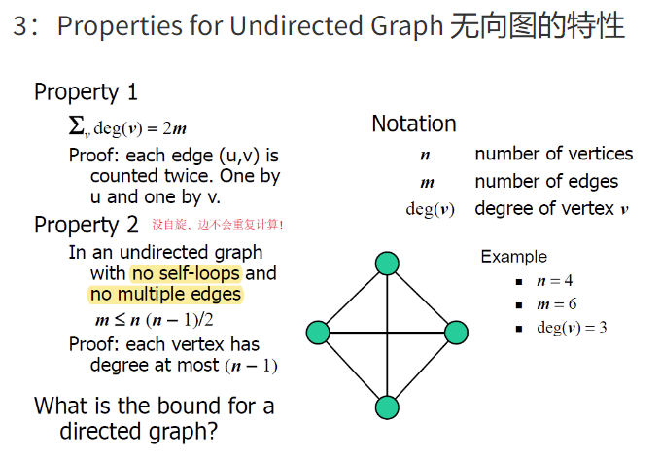

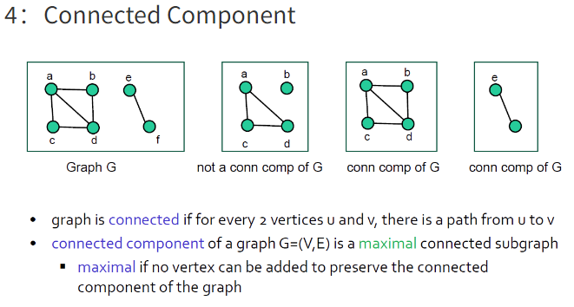

- how to represent internally (adjacency lists via vertex or edges, adjacency matrix)

4.1

-- explain/give runtime of operations on graphs that are represented by an adjacency list or adjacency matrix

4.1

- Graph Algorithms

-- Depth First Search (DFS)

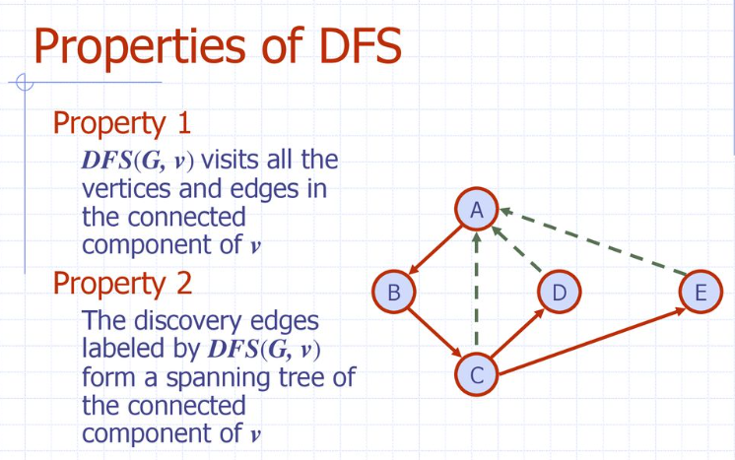

proof

-- Breadth First Search (BFS)

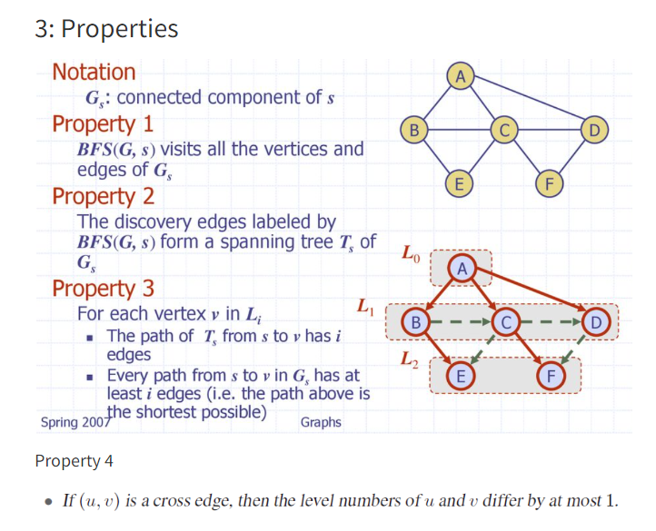

No proof

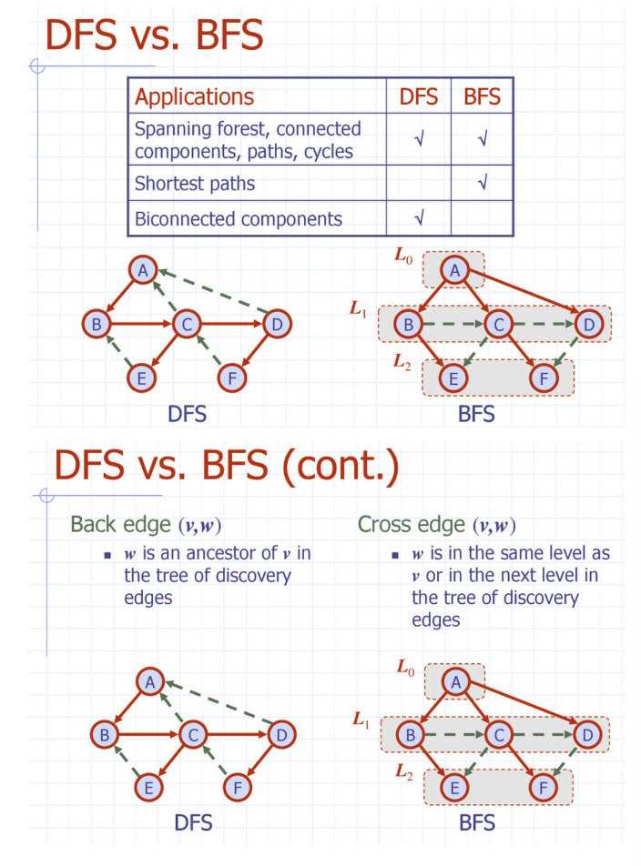

-- Directed DFS

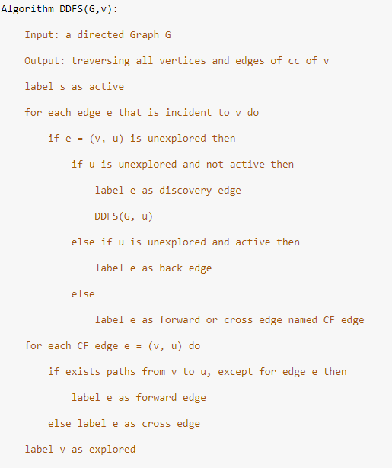

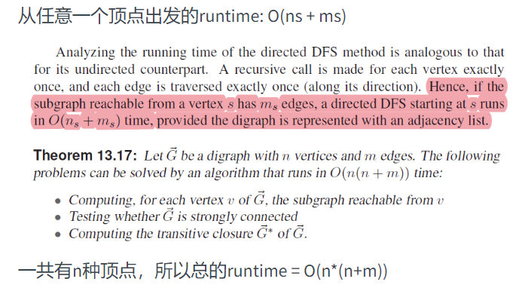

-- Directed BFS

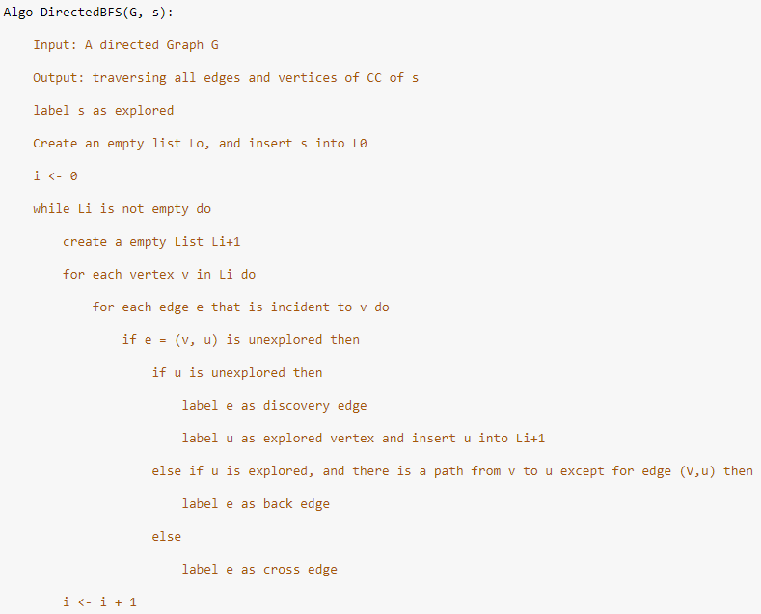

-- Topological Ordering

